Would you like to partner with your spiritual gifts in the house of the LORD

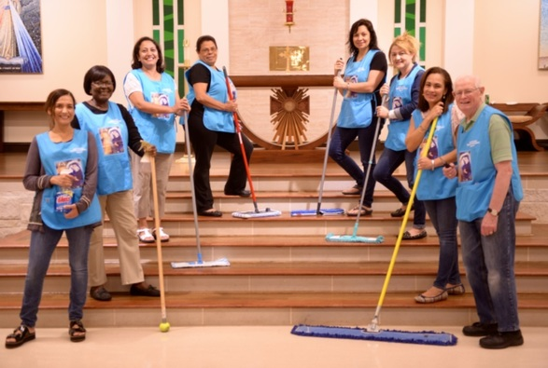

Media Team

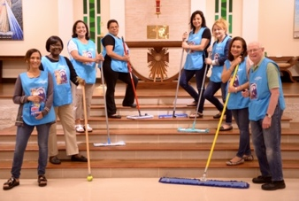
MEMBERSHIP FORM

PERSONAL INFO
Full Name & surname:
Address:
Area: | Code: /File No.
Date of Birth: | Age:
Nationality :
Identity Number :
Marital Status (please circle): SINGLE MARRIED DIVORCED WIDOWED
If Married, Date of Marriage:
Is your spouse a member of New Faith: YES NO |  | Date of Birth:
Spouse’ Name: |  | Date of Birth:
Name of Child 1: |  | Date of Birth:
Name of Child 2: |  | Date of Birth:
Name of Child 3:

EMPLOYMENT
Occupation:
Employer:
Home Tel No: | Work Tel No:
Cell No: | E-mail:

MINISTRY
Area of Ministry/Abilities:
Current Ministry Involvement:
Previous Ministry/Church:
If you’re under 21, do you have your parents’ consent to join this church (please circle): YES NO
How were you introduced to New Faith (please tick):
__ Relative __ Friend Name of Relative / Friend: _________________________________________
__ Facebook Other: ___________________________

Do you agree with the 5 Pillars of New Faith (please circle): YES NO
- Attend Church Regularly
- Pray for your leaders
- Evangelize
- Attend Bible Study
5. Tithe Faithfully

Do you agree with the Statement of Faith (please circle): YES NO
The Bible is the inspired and only infallible and authoritative Word of God.
There is only one God, eternally existent in three persons, God the Father, God the Son, God the Holy Spirit.
The deity of the Lord Jesus, His virgin birth, His sinless life, His miracles, His vicarious and atoning death, His bodily resurrection, His ascension to the right hand of God the Father, His personal future return in power and glory.
The only meaning of being cleansed from sin is through repentance and faith in the finished work of Jesus Christ.
The New birth of the Holy Spirit is absolute essential for personal salvation and eternal life.
The redemptive work of Christ on the cross provides healing for the human body.
The baptism of the Holy Spirit with evidence.

Signature: _________________________ (if married) co-spouse: _______________________

Date: _________________________

